**CO322: Data Structures and Algorithms**

**Lab 02: HR problems**

**WIJERATHNE E.S.G**

**E/18/397**

1. Grading Students

Here first I check for the value is greater than or equal to 38. If the value is less than 38, I let the value as it is. Otherwise, I check for the (value + 1) and (value + 2) modules is equal to 0. If it is I set that value to the nearest value which will be divided by 5. Otherwise, no change in the value.

1. The power sum

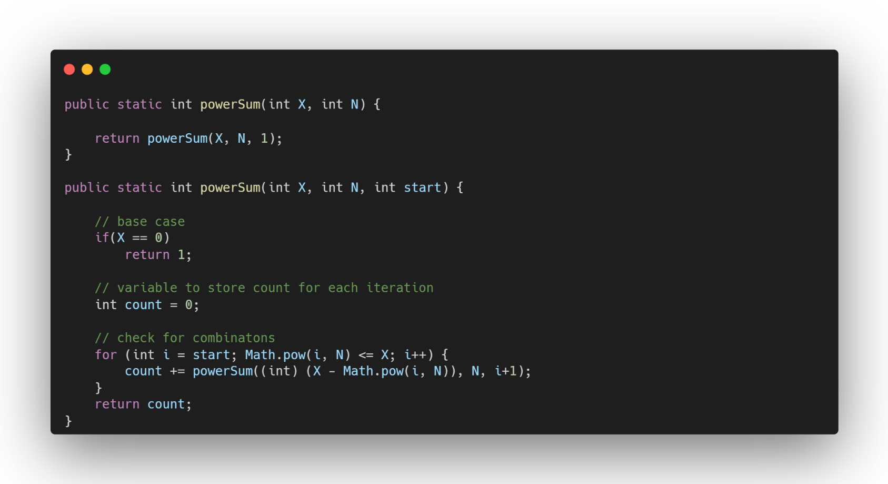

Start with examples X=13 and N=2. First, we start values with 12. We subtract that value from the X and then go to the next step. Now X = 12 and start = 2. Then I consider 12 – 22. Now I have X = 8 and the start value as 3. 32 = 9 and we cannot make 13. So we start considering other combinations using recursion.

1. Caesar Cipher

I have two strings with the simple and capital alphabet to get the positions of each letter. Then I am iterating through each letter and get relevant character positions. Once find the position get the relevant rotated letter position and a new letter will be added to the return string.

1. Climbing the Leaderboard

First, get the ranked list values to a set to eliminate duplicate values. Then those values will be sorted. Then I iterate through new player values and check that the corresponding rank values are according to the old list. Once find a rank it will be added to the output list.